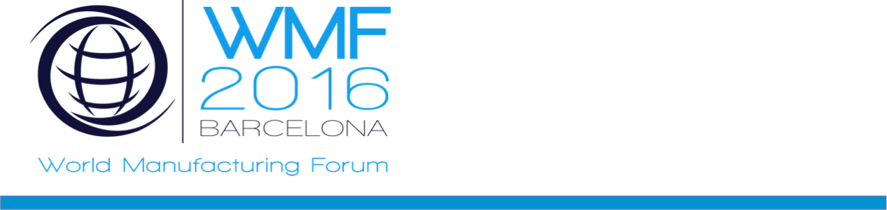

World Manufacturing Forum For Scholars

From Global Challenges to Grand Manufacturing Opportunities:
The leading response from the youngest minds

5th May 2016, Barcelona, Spain

How can industry accelerate advanced manufacturing in the era of smart, sustainable and inclusive growth?

The importance of manufacturing as a key contributor to economic wealth and growth has been recognized and elevated again as a priority in industrialized nations in the early 21st century. Innovation fueled by ever increasing customer demand drives research efforts toward increased productivity through the development and use of new technologies, whilst respecting the need for a more sustainable use of resources across the globe.
In this context, the World Manufacturing Forum brings together policy experts, industry leaders, as well as academic influencers across the globe to discuss the economic, social and technical challenges that will impact global manufacturing in the future.
For first time ever, the World Manufacturing Forum for Scholars will address the challenges affecting industry bringing the youngest minds to defy the manufacturing megatrends so to unveil innovative responses by using technological aspects like manufacturing intelligence, social innovation, circular Economy, zero-waste concepts and disruptive approaches for the future.
We look forward to seeing you there.

Please visit www.worldmanufacturingforum.org for more information.
Program Overview

Thursday, 5th May 2016

8:30 Arrival of the participants and Registration

Groups forming and split-up between parallel rooms

9-12:15 Start of the 3 Parallel Working Groups:

- Production Management - Brick Planner
- Sustainable Manufacturing – LifeCycle Assessment Game
- Advanced Materialisation - Space Machining

Starting Briefing to the groups
Work dynamics

(10:30-10:45) Breakfast Intermission

Work dynamics
Visits to Fundació CIM’s Pilot Plant
Recap and conclusion by parallel groups

12:30-13:35 WMF Plenary and Closing:

(12:30-12:40) Session Recap – Joaquim Minguella, Director of L&T Fundació CIM
(12:40-13:05) Speeches of 3 groups of students of the 3 parallel rooms
(13:05-13:15) WMF and WMF4S – Stefano Perini, Representative of MANU-SKILLS
(12:15-13:25) Educational aspects – Miquel Angel Essomba, Education Commissioner of the City of Barcelona
(13:25-13:35) Official Closure - Enric Fossas, Rector of the UPC

Diploma delivery upon badge return for re-uses

